

National University of Singapore

**EE5907: Pattern Recognition**

**Face Recognition**

**CA2 Report**

**Li Haipeng (A0260034W)**

**11/11/2022**

CONTENTS

1. Dataset 3

2. PCA for Feature Extraction, Visualization and Classification 3

a) PCA based data distribution visualization 3

b) PCA plus nearest neighbor classification results 5

3. LDA for Feature Extraction and Classification 5

a) LDA based data distribution visualization 5

b) LDA plus nearest neighbor classification results 6

4. SVM for Classification 7

5. Neural Networks for Classification (CNN) 7

References 10

1. Dataset

The dataset concludes 25 different subjects out of CMU PIE dataset and 10 personal face photos. The personal face photos are converted to gray-scale images and resized to (32,32). For each chosen subject, use 70% of the provided images for training and use the remaining 30% for testing.

The basic dataset preprocess code is in the dataset.ipynb. The information of the dataset is shown below.

Table 1.1 Dataset informations

|  |  |
| --- | --- |
| data_idx | [1, 2, 4, 7, 13, 14, 16, 17, 22, 23, 26, 27, 29, 33, 36, 43, 47, 50, 52, 53, 57, 58, 63, 66, 67] |
| Number of PIE images | 4250 |
| Number of PIE train images | 2975 |
| Number of PIE test images | 1275 |
| Number of self images | 10 |
| Number of self train images | 7 |
| Number of self test images | 3 |
| Number of whole train images | 2982 |

The raw face images will be converted to 1024 dimensional vector by the function get_img_vector.

1. PCA for Feature Extraction, Visualization and Classification
   1. PCA based data distribution visualization

Randomly sample 500 images from the CMU PIE training set and your own photos. Apply PCA to reduce the dimensionality of vectorized images to 2 and 3 respectively. Visualize the projected data vector in 2d and 3d plots. Highlight the projected points corresponding to your photo.

From the 2d plot, we can find that the red points are in the other points, which mean the self-photos are difficult to be classified if we only reduce the dimensionality to 2. From the 3d plot we can find that it is easy to draw the boundary between the self-photos and the CMU PIE images. However, it is still difficult to classify the 25 different classes of CMU PIE datasets

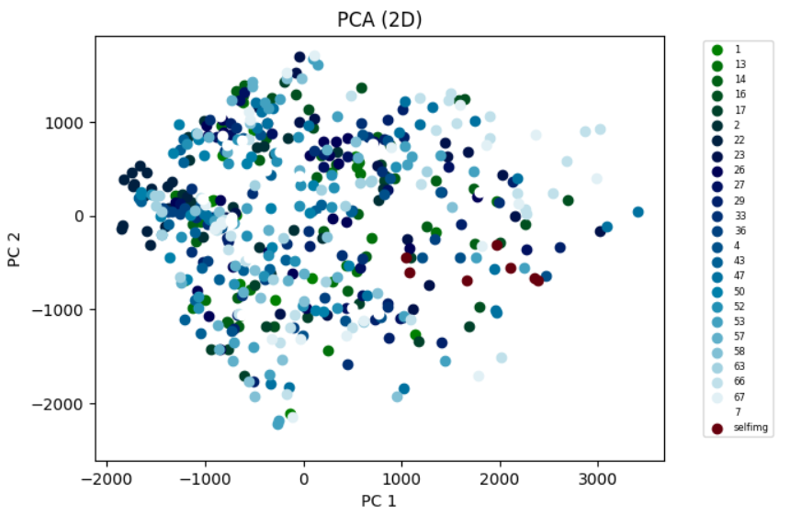

Fig 2. 1 Visualize the projected data vector in 2d plots

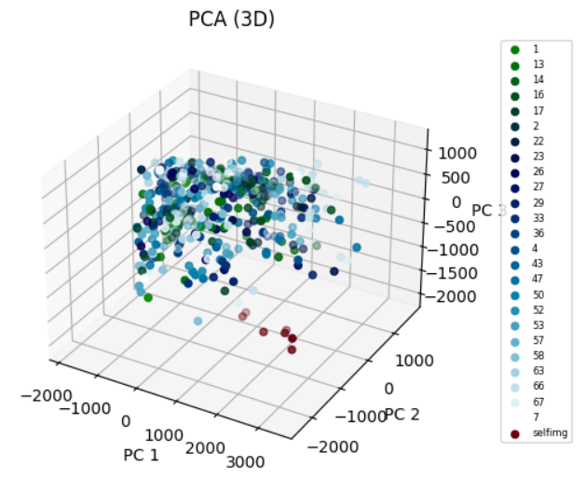

Fig 2. 2 Visualize the projected data vector in 3d plots

Visualize the corresponding 3 eigenfaces used for the dimensionality reduction. This three eigenfaces means the three most significant components extracted from the whole training image features.

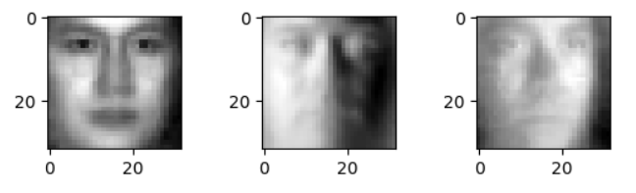

Fig 2. 3 Visualize the corresponding 3 eigenfaces

* 1. PCA plus nearest neighbor classification results

From the result, we can find the classification accuracy of self-photos is 100%, which is consistent with previous analysis in the 3d plot. With the larger dimensionality, there will be more principal components, and the accuracy will increase. After some discussion with other students, my test result is quite good, and it may be had something to do with the choice of the dataset.

Table 2. 1 Classification accuracy of PCA

|  |  |  |
| --- | --- | --- |
| Dimensionality | CMU PIE | Self |
| 40 | 94.98% | 100% |
| 80 | 96.55% | 100% |
| 200 | 96.86% | 100% |

1. LDA for Feature Extraction and Classification
2. LDA based data distribution visualization

Apply LDA to reduce data dimensionality from to 2, 3 and 9. Visualize distribution of the sampled data (as in the PCA section) with dimensionality of 2 and 3 respectively (similar to PCA). The dataset concludes 25 classes of CMU PIE images and 10 self-photos.

From the 2d and 3d plot, we can find the points of same class will gather together. Especially for the self-photos, the points almost overlap on each other, so it is easy to classify the self-photos from both plot. Besides with the dimensionality increases to 3, we can see from the 3d plot that the clustering effect is quite clear.

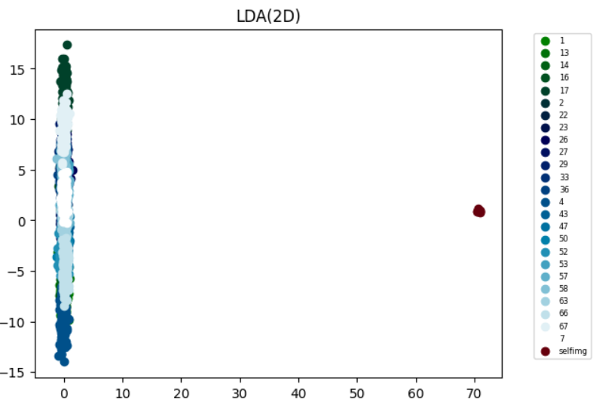

Fig 3. 1 Visualize the projected data vector in 2d plots

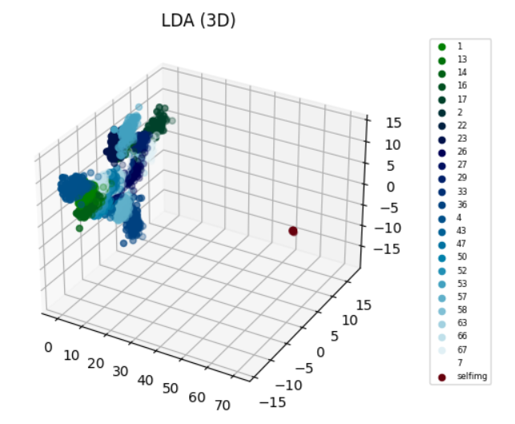

Fig 3. 2 Visualize the projected data vector in 3d plots

1. LDA plus nearest neighbor classification results

From the result we can find it is easy to classify the self-photos, which is the same with what we find from the plots. With the increase of dimensionality, the classification accuracy of CMU PIE test data will increase. Especially when the dimensionality comes to 9, the accuracy is already over 90%, which means that compared to PCA, LDA can use low data dimensionality to get a high accuracy.

Table 3. 1 Classification accuracy of LDA

|  |  |  |
| --- | --- | --- |
| Dimensionality | CMU PIE | Self |
| 2 | 44.71% | 100.0% |
| 3 | 60.78% | 100.0% |
| 9 | 92.39% | 100.0% |

1. SVM for Classification

Use the raw face images (vectorized) and the face vectors after PCA pre-processing (with dimensionality D of 80 and 200) as inputs to linear SVM. Try different penalty parameter C values of 0.01, 0.10, 1.00. The dataset concludes 25 classes of CMU PIE images and 10 self-photos. The result is shown below.

Theoretically, when the penalty parameter C is big, the tolerance for the wrong samples at the boundary will be lower and the fitting degree of the samples will be higher. On the contrary, when C is small, it is more likely to make wrong classification when training.

However, from the result, we find that the accuracy (with dimensionality of 80 and 200) is same and all quite high when we change the value of C.

From the table, we can notice that the more dimensionality, the higher accuracy will be. When dimensionality is 200, the accuracy is almost the same with the raw face images.

Table 4. 1 Classification accuracy of SVM

|  |  |  |  |  |
| --- | --- | --- | --- | --- |
| C | D = 10 | D = 80 | D = 200 | Raw face images |
| 0.01 | 77.543% | 98.9828% | 99.2958% | 99.2958% |
| 0.10 | 77.3865% | 98.9828% | 99.2958% | 99.2958% |
| 1.00 | 74.3349% | 98.9828% | 99.2958% | 99.2958% |

1. Neural Networks for Classification (CNN)

Train a CNN with two convolutional layers and one fully connected layer, with the architecture specified as follows: number of nodes: 20-50-500-21. The number of the nodes in the last layer is fixed as 26 as we are performing 21-category (25 CMU PIE faces plus 1 for yourself) classification. Convolutional kernel sizes are set as 5. Each convolutional layer is followed by a max pooling layer with a kernel size of 2 and stride of 2. The fully connected layer is followed by ReLU. Train the network and report the final classification performance.

Use tensorflow to create the CNN model. Reshape the data to (, 32, 32, 3) by the function get_img().The result is shown below.

We can find that after two epochs, the training accuracy is over 90%. The accuracy of the testing set is 98.45%, which is the best among these four methods.

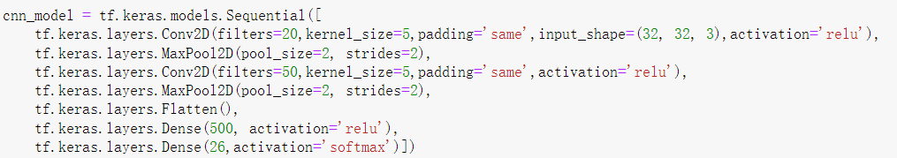

Fig 5. 1 CNN model deployment

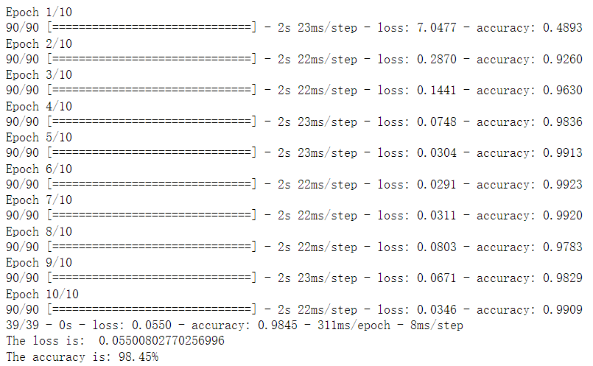

Fig 5. 2 Train and test result of CNN model

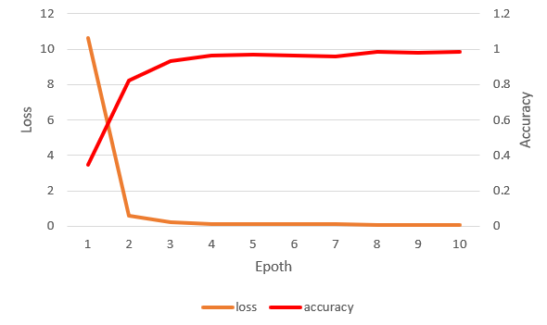

Fig 5. 3 Training loss curves and accuracy curve of the CNN model

Change the network architectures, and use VGG network to train our dataset. The VGG network was proposed by Visual Geometry Group from University of Oxford in 2015[1]. The ConvNet configurations of VGG network is shown in the table below. Choose A configurations, which contains 11 weight layers. Considering that our input is only image, so remove 2 max pooling layers. The model deployment is shown in Fig 5.4.

Table 5.1 ConvNet configurations [1]

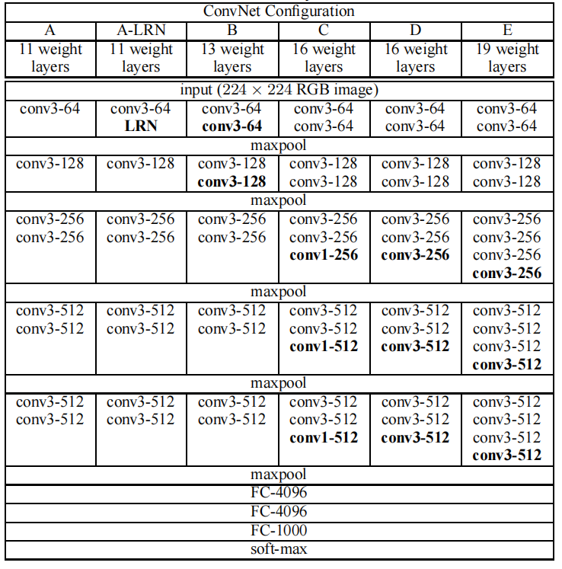

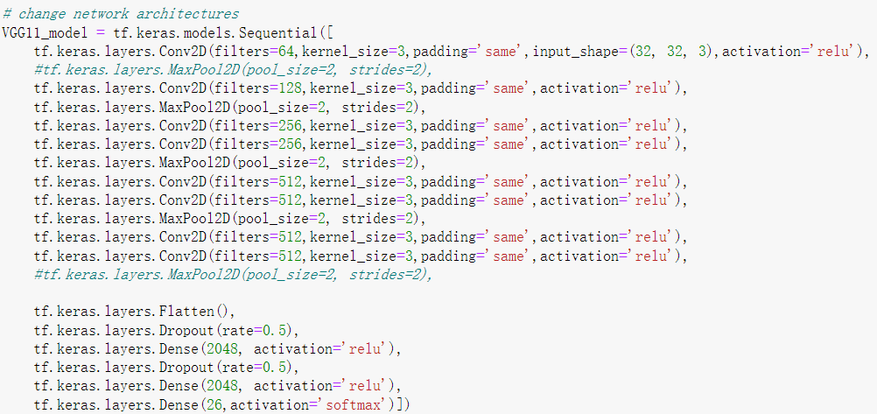

Fig 5.4 VGG network model deployment

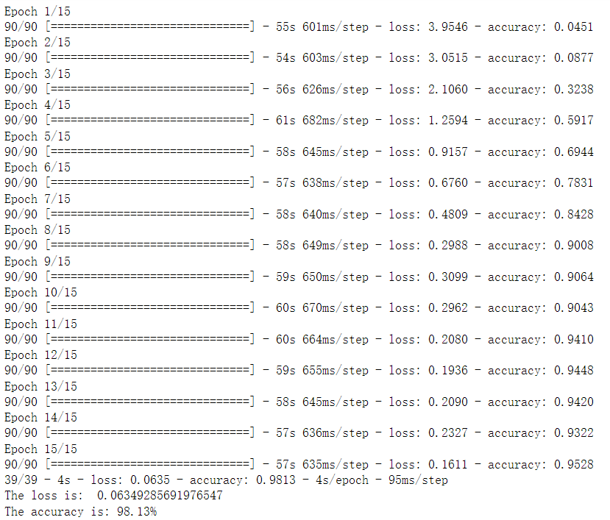

Fig 5.5 Train and test result of VGG network model

From the result we can see that VGG network is more time-consuming because of its bigger and more convolution layer. The accuracy is high after 10 epochs and accuracy on the test set is 98.13%, which is the same with the simple CNN model. However, our datasets are small and simple, which only contains 2863 training data and the size of input data only . Therefore, it is unsuitable to use VGG network model for our dataset.

References

1. Simonyan, Karen, and Andrew Zisserman. "Very deep convolutional networks for large-scale image recognition." arXiv preprint arXiv:1409.1556 (2014).